**Create a repositories**

To put your project up on GitHub, you'll need to create a repository for it to live in.

You can store a variety of projects in GitHub repositories, including open source projects. With [open source projects](http://opensource.org/about), you can share code to make better, more reliable software.

**Note:** You can create public repositories for an open source project. When creating your public repository, make sure to include a [license file](http://choosealicense.com/) that determines how you want your project to be shared with others. For more information on open source, specifically how to create and grow an open source project, we've created [Open Source Guides](https://opensource.guide/) that will help you foster a healthy open source community by recommending best practices for creating and maintaining repositories for your open source project. You can also take a free [GitHub Learning Lab](https://lab.github.com/) course on maintaining open source communities.

1. In the upper-right corner of any page, use the  drop-down menu, and select **New repository**.

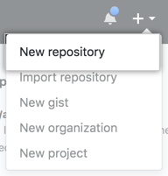

1. Type a short, memorable name for your repository. For example, "hello-world".

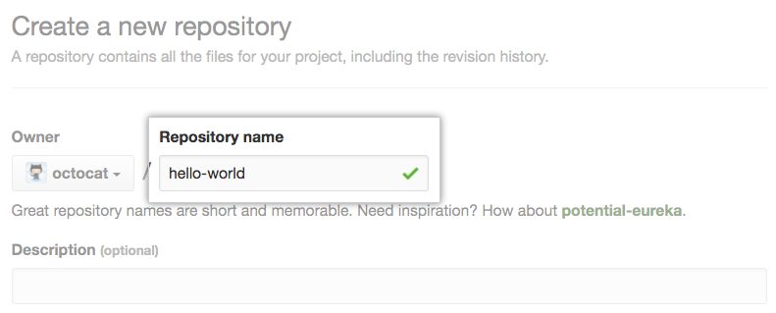

1. Optionally, add a description of your repository. For example, "My first repository on GitHub."

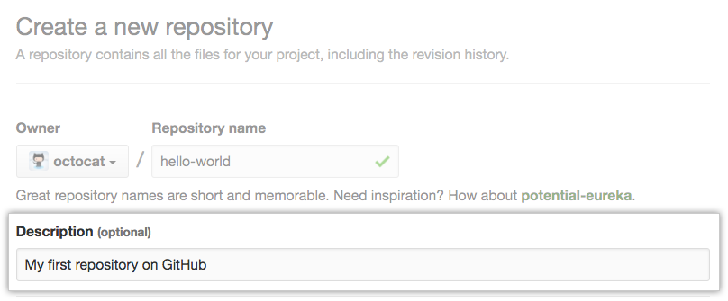

1. Choose a repository visibility. For more information, see "[About repository visibility](https://docs.github.com/en/free-pro-team@latest/github/creating-cloning-and-archiving-repositories/about-repository-visibility)."

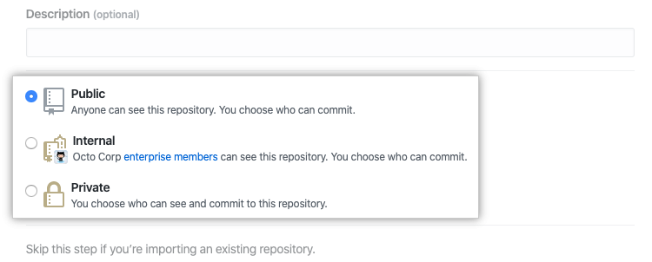

1. Select **Initialize this repository with a README**.

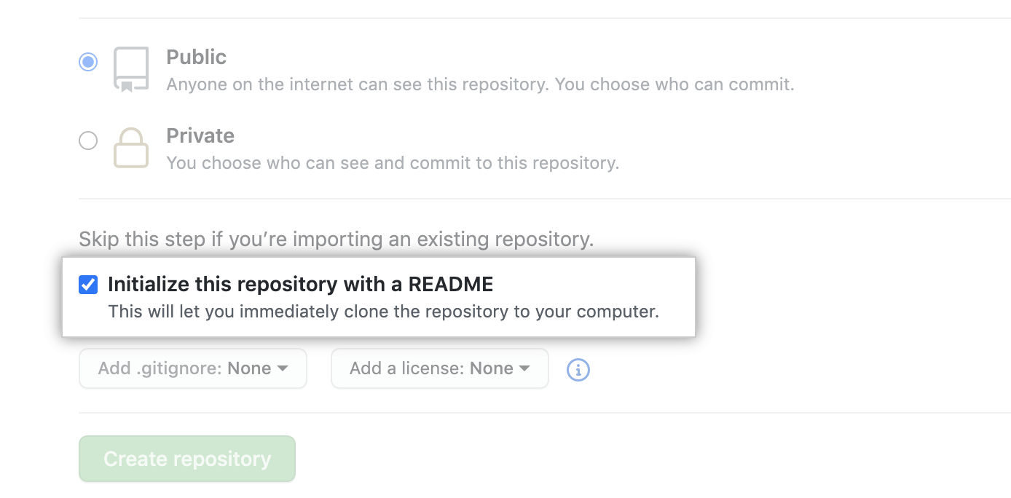

1. Click **Create repository**.

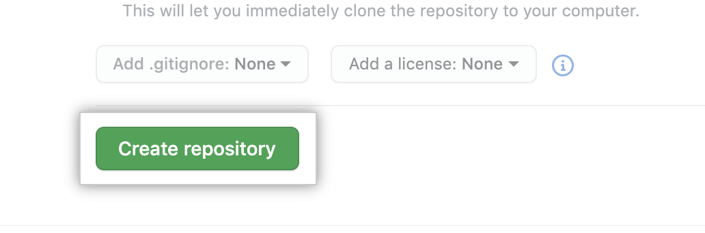

Congratulations! You've successfully created your first repository, and initialized it with a README file.

**Tip**: You can also create repositories using the GitHub CLI. For more information, see "[gh repo create](https://cli.github.com/manual/gh_repo_create)" in the GitHub CLI documentation.

### [**Commit your first change**](https://docs.github.com/en/free-pro-team@latest/github/getting-started-with-github/create-a-repo#commit-your-first-change)

A [*commit*](https://docs.github.com/en/free-pro-team@latest/articles/github-glossary#commit) is like a snapshot of all the files in your project at a particular point in time.

While you created your new repository, you initialized it with a READ ME file. READ ME file are a great place to describe your project in more details, or add some documentation such a how to install or used your project. The contents of your READ ME file are automatically show on the front page of your repository

Let’s commit a change to the README file .

1. In your repository's list of files, click **README.md**.

